
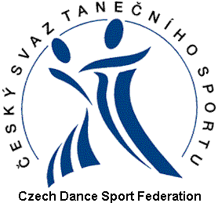

Entry Form

WDSF World PD Latin Championship
Ostrava, October 12th 2013

Member Association
Gentleman |  |  |  |  |  |  |  |  | Lady
WDSF MIN |  |  |  |  |  |  |  |  | WDSF MIN
Address |  |  |  |  |  |  |  |  | Address
Mobile |  |  |  |  |  |  |  |  | Mobile
Email |  |  |  |  |  |  |  |  | Email
Date of Birth (dd/mm/yyyy) |  |  |  |  |  |  |  |  | Date of Birth (dd/mm/yyyy)
Passport No |  |  |  |  |  |  |  |  | Passport No
Date, place of issue |  |  |  |  |  |  |  |  | Date, place of issue

Visa needed YES/NO

This entry form has to be sent through WDSF member body to Czech Dance Sport Federation office: sekretariat@csts.cz by September 20th 2013.

